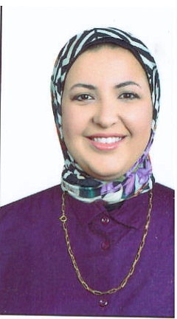
Marwa Abd AL-Aziz (UI/UX)

Contact: 01009530952
Email:  Marwa_abdalaziz@yahoo.com

Objectives |  | In search of position of engineering graduate that will offer me excellent opportunity and challenge.
Personal Information  Education |  | - Date of birth: 26th of March 1987.  - Age: 32 years.
June 2009 B. SC. In Engineering and Technology
in Electrical Engineering Specialization
) Computer Engineering and Information Technology(
Modern Academy for Engineering and Technology
Good 66.31 %
July 2004 General secondary education certificate
Abraq-Khaitan School ,Kuwait.

Project |  | Real time tracking system based on GPS/GSM Technology  The Project Consist of :  - Sender (the vehicle)  - Receiver (which Tracking the vehicle). Excellent.
Training Experience |  | - Training Experience - Completed the requirements studies of Electronic Courses fundamental ( 30 Hrs). summer 2006.  - Attended Managing and maintaining a Microsoft Windows Server 2003 (70-290) summer 2007.  - Attended and complete the ORACLE SQL. summer 2008 .  - Udemy course web developer bootcamp  - Frontend Development Intern in Bit 68, Heliopolis, 2018 summer 1 month.
Work Experience  Languages |  | - Egyptian language school 5th district - Computer teacher in 2012 -2014 / 2022 – present.  - premier semi-international school 2017-2018  - Giraffe code company – Frontend Developer (Angular) 2018-2020.  Arabic: Mother tongues.  English: very good Reading, Writing and Speaking.
Skills |  | - Computer skills: Well oriented with Office,Premiere pro, After effect,  Blender,figma.  - Programming Languages: Scratch,C++, HTML, CSS, JS, Angular.  - Communication skills.

